**Global Economic and Demographic Trends Analysis**

**1.Context**

This project focuses on analysing global data related to population, GDP, literacy, health indicators, and more. The data is sourced from multiple Excel files and a SQL database. The aim is to explore and visualize trends using Power BI to support data-driven insights about countries across the world.

**2.Objective**

To create a Power BI report and dashboard that provides meaningful insights into global economic and demographic patterns by analysing data from different countries over time. The final outcome should help understand trends in population, GDP, health, and literacy.

**3.Scope**

* Integrate and analysed datasets from both Excel and SQL.
* Perform data cleaning, transformation, and merging of datasets.
* Conduct basic descriptive statistical analysis.
* Use DAX calculations for deeper insights.
* Build an interactive Power BI dashboard with at least 5 types of visualizations.
* Present findings through a PowerPoint and a written report.

**4.Audience:**

* Data analysts and business intelligence professionals.
* Policy makers or researchers studying global development.
* Project mentors, evaluators, and academic faculty.

**Techniques Used**

* **Data Integration**: Combining Excel and SQL datasets in Power BI.
* **Data Cleaning & Transformation**: Removing duplicates, handling missing values, changing data types.
* **Descriptive Statistics**: Mean, median, mode, standard deviation, etc.
* **DAX (Data Analysis Expressions)**: Calculations for growth rates, GDP per capita, etc.
* **Data Visualization**: Bar charts, line graphs, maps, pie charts, and interactive elements like slicers and filters.
* **Storytelling**: Power BI storytelling features to narrate insights.
* **Presentation**: Creating a PowerPoint summarizing datasets, visualizations, and key findings.

**6. Dataset Overview**

**1. Countries World Dataset (SQL)**

This dataset contains country-wise information related to geography, population, economy, and health indicators. It includes the following fields:

* Country & Country Code
* Region
* Population, Area, Population Density
* Coastline Ratio, Net Migration
* Infant Mortality (per 1000 births)
* GDP ($ per capita)
* Literacy (%), Phones (per 1000 people)
* Land Usage (% Arable, Other)
* Climate, Birthrate, Deathrate
* Sectoral GDP (% from Agriculture, Industry, Service)

This dataset is stored in SQL format and will be connected to Power BI for analysis.

**2. PopulationPerCountry Dataset (Excel)**

This Excel file includes:

* Country Name & Country Code
* Indicator Name & Code
* Year-wise population data from **1960 to 2017**

It helps analyse long-term **population growth trends** across countries.

**3. Metadata Dataset (Excel)**

This metadata file provides contextual information about countries such as:

* Country Name & Code
* Region
* Income Group
* Special Notes (e.g., data availability or anomalies)

It is useful for segmenting and filtering data based on **region or income levels**.

**4. GDP by Country Dataset (Excel)**

This file contains:

* Country Name & Code
* Indicator Name & Code
* Year-wise GDP data from **1960 to 2016**

It supports **GDP trend analysis** over time and helps compare **economic growth** across nations.

**7.Data Cleaning**

To ensure the datasets were suitable for analysis in Power BI, several data cleaning and transformation steps were performed:

1. **Handling Null Values**
   * For fields like literacy rate and sectoral GDP (Agriculture, Industry, Service), missing values were filled using appropriate formulas based on related fields or averages where applicable.
2. **Population and GDP Datasets**
   * These datasets were originally structured with years as columns (wide format). They were transposed and unpivoted to convert them into a long format, which is required for effective time series analysis.
   * Instead of using mean or median to fill missing values (which would distort trends), forward-fill or backward-fill techniques were used. This means missing values were filled using the values from the previous or next year to maintain a logical flow in the time series data.
3. **Data Filtering**
   * The datasets included both countries and regions. To avoid confusion and inconsistency in the analysis, non-country entries (regions) were removed.
   * Additionally, rows with incomplete or irrelevant data were excluded to improve accuracy.
4. **Standardization of Units**
   * Some data fields were partially in absolute values and partially in percentages. These were standardized by converting all relevant values into percentage format, ensuring uniformity across the dataset.
5. **Data Structuring**
   * After cleaning, the datasets were merged and related using common keys like Country Name and Country Code.
   * This allowed for country-wise aggregation and the calculation of average values across all years, which helped in identifying population and GDP trends over time.

**8.Dashboards**

**1. Population Analysis Dashboard**

**Overview:**

This dashboard provides a comprehensive analysis of population trends across countries from 1960 to 2017.

**Key Insights:**

* **Top Populated Countries:** China and India consistently have the highest mean and median populations, each exceeding 1 billion.
* **Growth Trend:** Population growth rate peaked around the 1960s and has steadily declined in recent decades.
* **Variation:** Standard deviation is highest in India and China, indicating significant population changes over time.
* **Trend Analysis:** Countries like the United States, Indonesia, and Brazil also show steady increases in population over the years.
* **Descriptive Stats:** The global average population is approximately **23.83M**, with a median of **4.09M** and a high standard deviation of **99.91M**, showing large differences between countries.

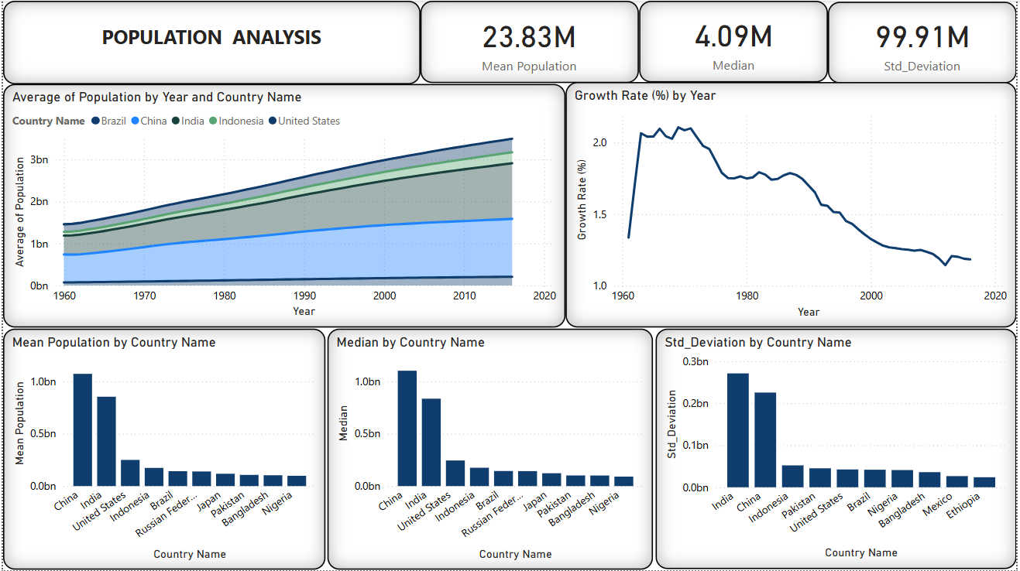

**2. GDP by Country Analysis Dashboard**

**Overview:**

This dashboard explores GDP trends and comparisons between countries and income groups over time.

**Key Insights:**

* **Highest GDP:** The United States has the highest GDP, reaching up to **$18.62 trillion**, while Tuvalu has the lowest at around **$8.82 million**.
* **GDP Leaders:** Countries like Japan, China, Germany, and France follow the U.S. in terms of average GDP.
* **Trend Line:** Average GDP has grown significantly since the 1980s, especially in developed nations.
* **Growth Rate:** GDP growth rate shows periodic spikes and declines, with notable peaks during the 1970s and 1990s.
* 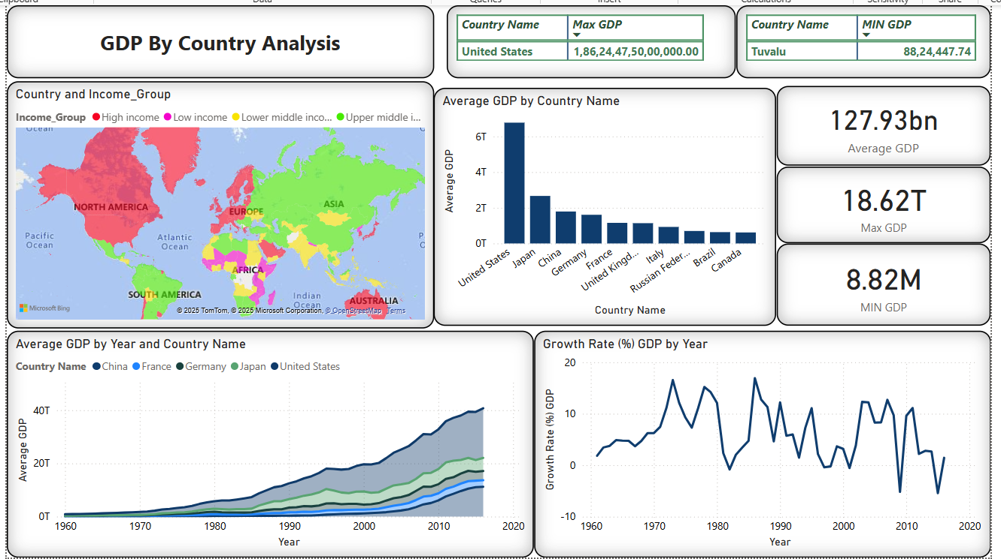**Global Distribution:** The map visualization highlights regional differences in income group distribution.

**3. Region-wise Analysis Dashboard**

**Overview:**

This dashboard provides regional-level comparisons for demographic, agricultural, and economic indicators.

**Key Insights:**

* **Population Density:** Asia (excluding the Near East) and Western Europe have the highest population densities.
* **Arable Land:** Eastern Europe and the Baltics have a high percentage of arable land.
* **GDP per Capita:** Northern America and Western Europe show the highest average GDP per capita, indicating better economic conditions.
* **Birthrate and Deathrate:** Regions like the Baltics and Eastern Europe have high birth and death rates.
* **Population Distribution:** Asia dominates in terms of total population, followed by Northern America and Northern Africa.

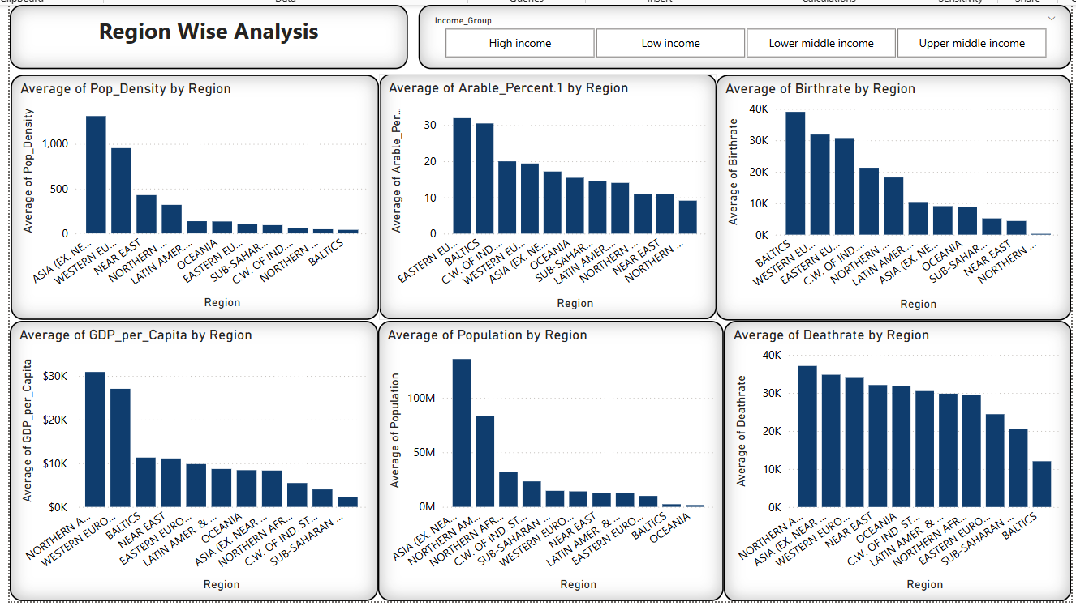

**4. Infant Mortality Analysis Dashboard**

**Overview:**

This dashboard focuses on infant mortality rates and their correlation with GDP per capita and climate types.

**Key Insights:**

* **Extreme Cases:** Angola has the highest average infant mortality rate (~191), while some island nations have rates as low as 3.
* **Correlation:** There is a **negative correlation** between infant mortality and GDP per capita—wealthier countries generally have lower infant mortality.
* **Climate Impact:** Over 60% of infant mortality cases occur in tropical climates.
* **Regional Concerns:** Countries like Sierra Leone, Mozambique, and Liberia show consistently high infant mortality rates.

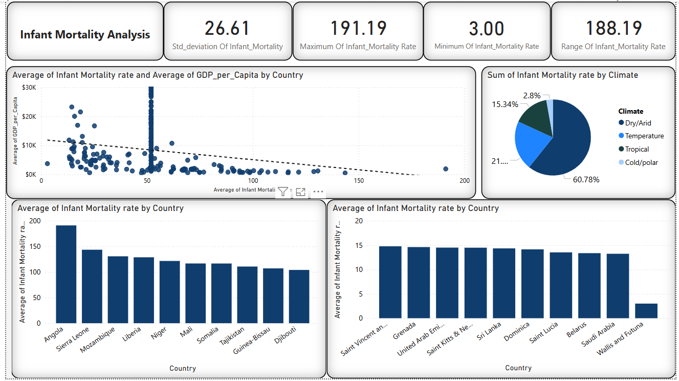

**5.Net Migration Analysis**

**Overview:**

This dashboard investigates the net migration trends across countries and income groups and their relationship with GDP per capita.

**Key Insights:**

* **Positive Correlation with GDP per Capita:**
  + The scatter plot shows a **positive trend** between GDP per capita and net migration.
  + Countries with **higher GDP per capita** tend to attract more migrants, likely due to better employment opportunities, healthcare, and living conditions.
* **Top Migrant-Receiving Countries:**
  + Countries such as **French Guiana, Hong Kong, Belgium, Slovenia, Italy, Malta, and Switzerland** have the highest average net migration rates.
  + These are mostly **high-income nations**, indicating they are more desirable destinations for migrants.
* **Countries with High Emigration (Negative Net Migration):**
  + **Micronesia, American Samoa, and Dominica** have the most negative net migration rates, meaning people are moving out of these countries at a higher rate.
  + These countries often have **lower GDP per capita**, smaller economies, and limited infrastructure.
* **Income Group Breakdown:**
  + **High-income countries** account for **74.69%** of positive net migration on average.
  + In contrast, **low and lower-middle income countries** show negative or very low net migration rates, highlighting economic disparity as a key driver of migration.

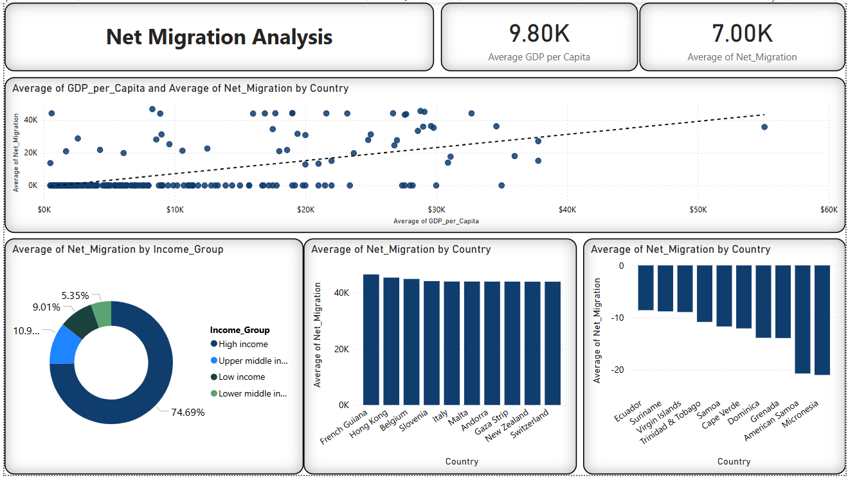

**6. Emigration Analysis (Dashboard 1)**

**Overview:**

This dashboard highlights net migration data and compares it with various socio-economic indicators.

**Key Insights:**

* **Top Emigration Countries:** Micronesia and American Samoa have the highest negative net migration, meaning more people are leaving than entering.
* **Associated Factors:**
  + These countries often have **low GDP per capita** and **moderate-to-high infant mortality**.
  + Literacy rates remain relatively high despite high emigration, suggesting people are moving for better opportunities, not due to lack of education.
* **Birth & Death Rates:** Some of these countries also show high birth and death rates, contributing to population pressure and migration.

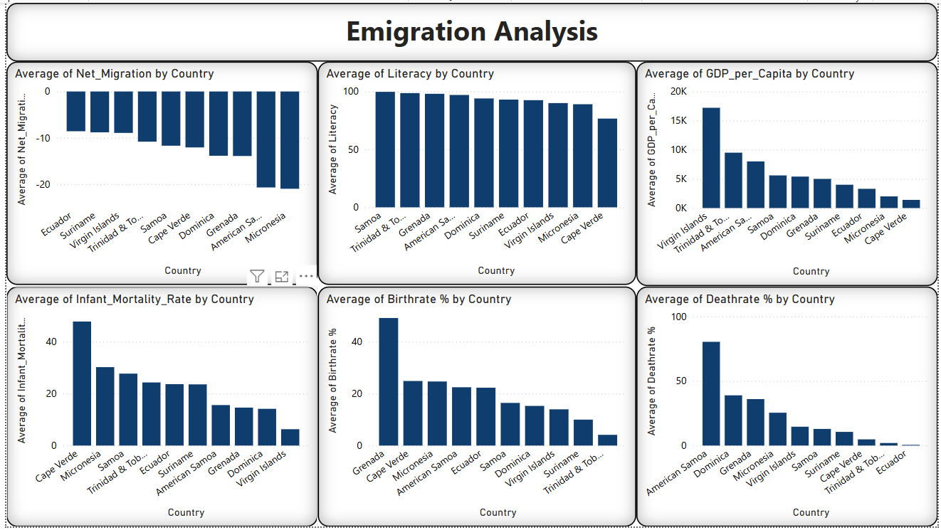

**7. Emigration Analysis (Dashboard 2)**

**Overview:**

This extended view adds more dimensions to the emigration story, including area, economic sector contributions, and population density.

**Key Insights:**

* **Average Net Migration**: Stands at **-3.18**, indicating an overall negative migration trend in selected countries.
* **Population Pressure:** Countries with high **population density** and low GDP per capita (like Grenada and Trinidad) show high emigration.
* **Economic Composition:** Many of these countries have a high share of GDP from **services and agriculture**, suggesting limited industrial opportunities.
* **Income Group Split:** Most emigrating countries fall under **lower-middle** and **upper-middle income** groups.

**Reason for Emigration:**

Based on your dashboard analysis, the **main reasons for emigration** appear to be:

* Limited economic opportunities
* Low GDP per capita
* High birth rates and infant mortality
* Small land area with high population density
* Lack of diversified industrial sectors

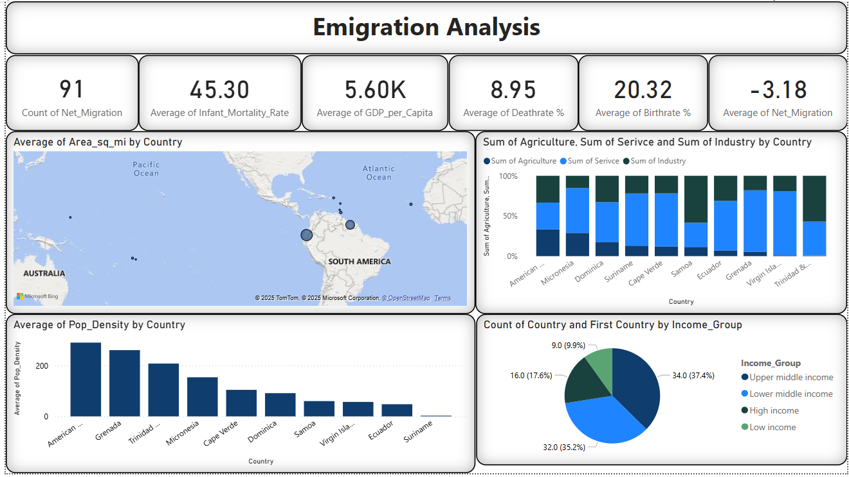

**8. Literacy Rate Analysis**

**Overview:**

This dashboard focuses on literacy rates across countries and their relationship with GDP per capita and income groups.

**Key Insights:**

* **Global Literacy:** The average literacy rate is **83.33%**, with countries like Andorra, Finland, and Norway reaching **100%**.
* **Low Literacy Countries:** Countries such as Burkina Faso, Niger, and Mayotte show significantly lower literacy rates.
* **Income Group Influence:** High-income and upper-middle-income groups contribute the most to global literacy totals.
* **GDP Link:** There's a clear **positive correlation** between GDP per capita and literacy rate—wealthier countries tend to have higher literacy levels.

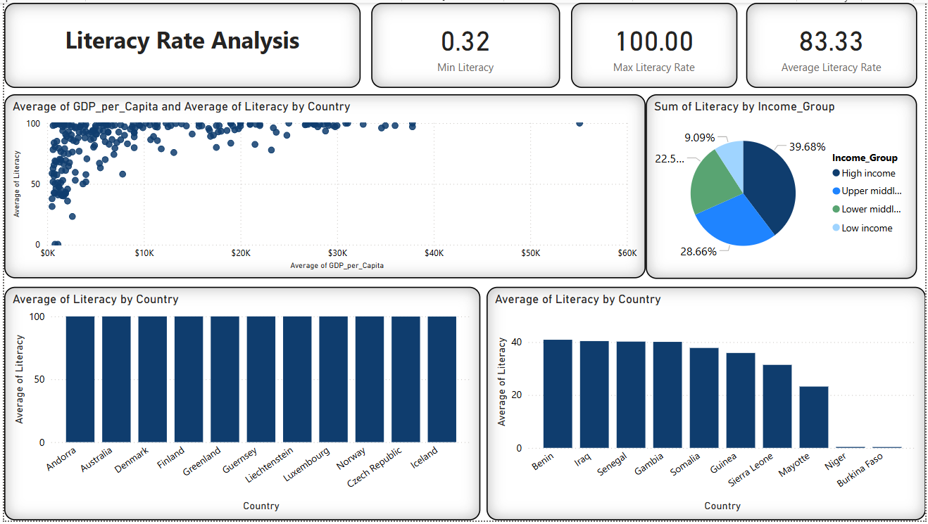

**9. Population and GDP Relation Analysis**

**Overview:**

This dashboard explores the relationship between population, GDP, area, and GDP per capita.

**Key Insights:**

* **No Direct Correlation:** High population does not always mean high GDP. For instance, China and India have huge populations but differ significantly in GDP per capita.
* **Area and GDP:** Larger countries like Russia and Canada don’t always have high GDP per capita, showing that land area alone isn’t a key driver of wealth.
* **GDP per Capita Drivers:** Countries like Luxembourg, Norway, and the U.S. have **high GDP per capita despite smaller populations**, emphasizing productivity and economic development over size.

**Relationship Between Population & GDP:**

There is no strong direct relationship between total population and GDP. However, GDP per capita is a much more meaningful indicator of a country's economic strength and standard of living.

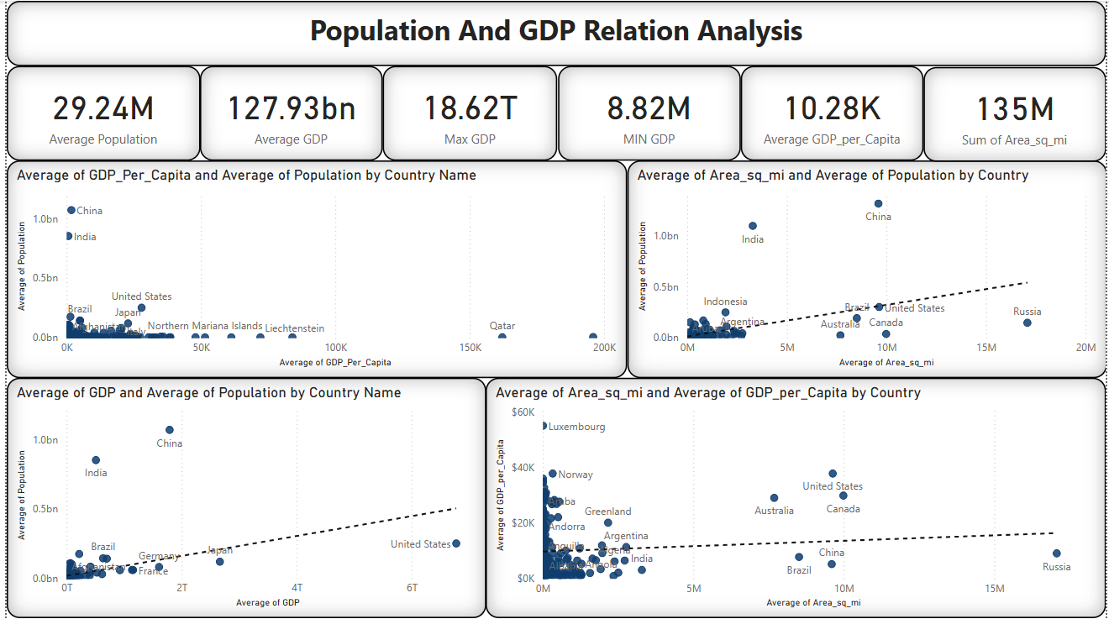

**10. Coastal Development & Global Trends**

**1. Coastline vs GDP per Capita**

* Countries with long coastlines (like Albania, Reunion, Marshall Islands) do not necessarily have high GDP per capita.
* Some land-rich or landlocked countries like the Netherlands and UK have higher GDP per capita, showing coastline alone doesn’t drive economic prosperity.

**2. Coastline vs Population**

* A long coastline doesn’t mean a high population. For example, Albania has a high coastline ratio but a much smaller population than the UK or North Korea.
* Population is more influenced by land area, urban infrastructure, and economy, not just coastline access.

**3. Coastline vs Area**

* Some small countries with long coastlines (like Marshall Islands) show a high coastline-to-area ratio, but their economic and population scales remain low.
* Large countries like Papua New Guinea may have significant coastline but low GDP and literacy, showing coastline alone doesn’t guarantee development.

**4. Coastline vs Literacy**

* Countries with higher literacy like the Netherlands and UK also tend to have higher GDP per capita, but their coastline ratios are moderate.
* This suggests that education and service sector strength have a stronger influence on development than coastline length.

**5. Economic Sectors Insight**

* Service sector dominates in developed countries regardless of coastline.
* Countries with higher coastline ratios don’t show a strong pattern of having more agriculture, industry, or service contributions.

**Global Trends Support:**

* GDP per Capita has increased steadily over time (as seen in the line chart), but this is more aligned with industrialization and service growth, not geography.
* Climate and region play stronger roles in economic and demographic trends than coastline.
* While coastline can offer strategic advantages (like trade or tourism), your analysis shows it doesn’t have a strong direct impact on GDP, population, or literacy. Factors

like economic structure, education, and regional development have greater influence on national prosperity.

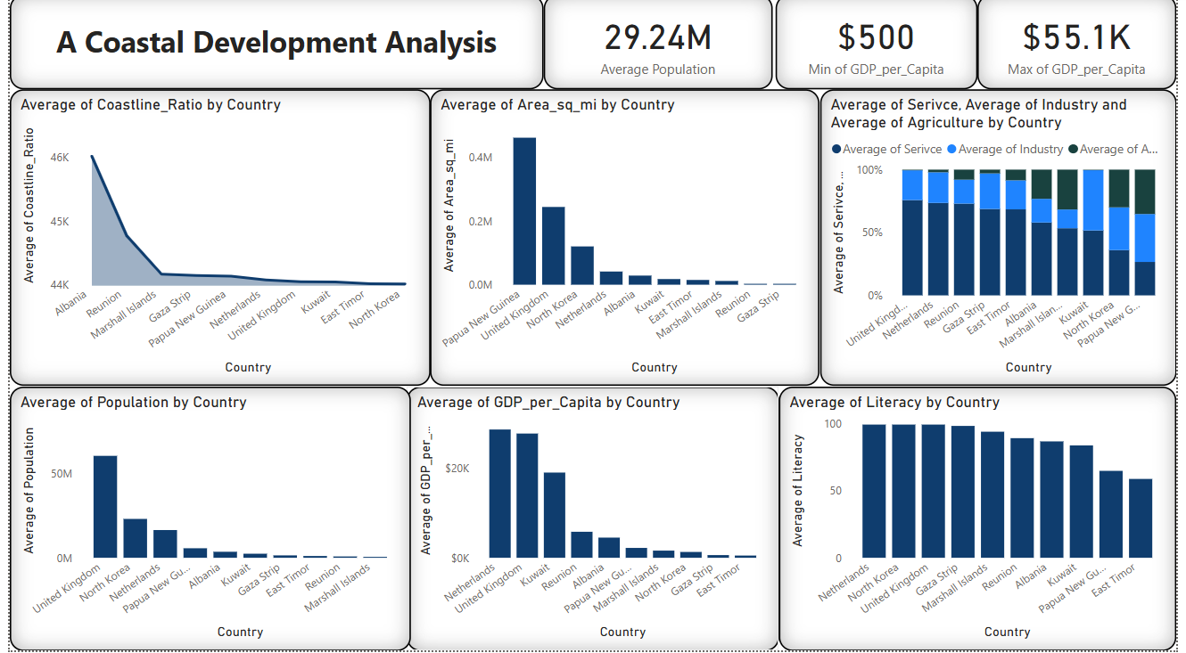

**11.Global Economic and Demographic Trends**

**Key Insights**

* GDP per capita is rising over time, especially after 2000.
* Service sector is strongest across most regions compared to agriculture and industry.
* Higher agriculture doesn’t mean more arable land – there’s no strong pattern.
* China and India have huge populations, but their GDP per capita is still low.
* Climate varies by region, but economic performance doesn’t directly depend on it.

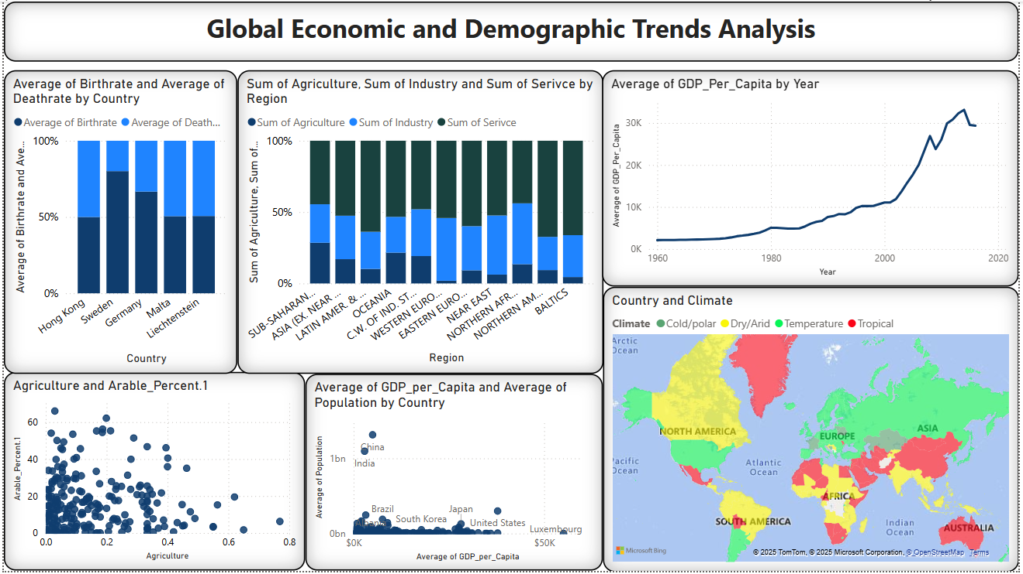

**9.Key Insights**

This project revealed important global patterns across population, GDP, literacy, migration, and development indicators:

* **Population Trends**: China and India dominate in population size, but high population doesn’t directly relate to higher GDP. Global population growth is slowing, and population variance between countries is significant.
* **GDP Insights**: The U.S. leads in overall GDP, while GDP per capita shows more about a country’s economic strength. Economies have grown steadily, especially in high-income countries, driven largely by the service sector.
* **Regional Patterns**: Regions like Asia and Western Europe have high population density. Northern America and Western Europe lead in GDP per capita. High arable land doesn't always correlate with agriculture-based economies.
* **Infant Mortality**: There is a clear negative relationship between infant mortality and GDP per capita. Higher economic development and literacy reduce infant deaths, especially in temperate and high-income regions.
* **Literacy and Development**: Higher literacy rates are strongly associated with higher GDP per capita. High-income countries show near 100% literacy, while many low-income nations lag far behind.
* **Migration Dynamics**: Economic factors like low GDP and limited opportunities are key drivers of emigration. Countries with strong economies attract more migrants, while small or developing nations often face negative net migration.
* **Coastline & Development**: Long coastlines do not guarantee economic growth or high literacy. Countries with strong education systems and service economies (like the UK and Netherlands) outperform many coastal nations.
* **Population vs GDP**: There's no strong link between population size and GDP. Small nations with efficient economies can outperform large, populous countries. GDP per capita and literacy are stronger indicators of prosperity.
* **Net Migration**: Countries with higher GDP per capita and better living conditions attract more migrants. High-income countries account for the majority of positive net migration.

**10. Conclusion**

This analysis shows that while coastal access can offer geographic and trade advantages, it does not guarantee economic development or population growth. Key drivers of national progress are education (literacy), economic structure (especially service sector strength), and land area.

Over time, GDP per capita has risen globally, driven more by industrialization, service sector expansion, and policy reforms than natural geography like coastline or climate.

In summary, human development, governance, and economic planning play a much stronger role in growth than location or natural features alone.

By,

YAHAVARSHINI E

22/04/2025